## Lab 7-01: Explore the Azure IoT Hub and Register a Device

### Service Introduction

GreenGrid Farms, a pioneering vertical farming company, faced a crucial challenge: maximizing crop yield and resource utilization while minimizing environmental impact. Their existing data collection system, relying on disparate sensors and manual data analysis, lacked the real-time insights and centralized control needed for optimal efficiency.

### Problem

GreenGrid's sensor data was scattered across individual greenhouses, hindering centralized monitoring and analysis. Manual data collection was time-consuming and prone to errors. The manual analysis process limited GreenGrid's ability to translate data into actionable insights for optimizing irrigation, temperature, and nutrient levels, leading to suboptimal yields.

### Solution

GreenGrid Farms' success story showcases the power of Azure IoT Hub for organizations seeking to leverage the IoT for data-driven decision-making and operational efficiency. By centralizing data, gaining real-time insights, and automating actions, GreenGrid achieved higher yields, reduced environmental impact, and optimized its operations, solidifying its position as a leader in the sustainable agriculture industry.

1. Log in to **Azure** Portal and go to the portal home page. Click on **IoT Hub**.

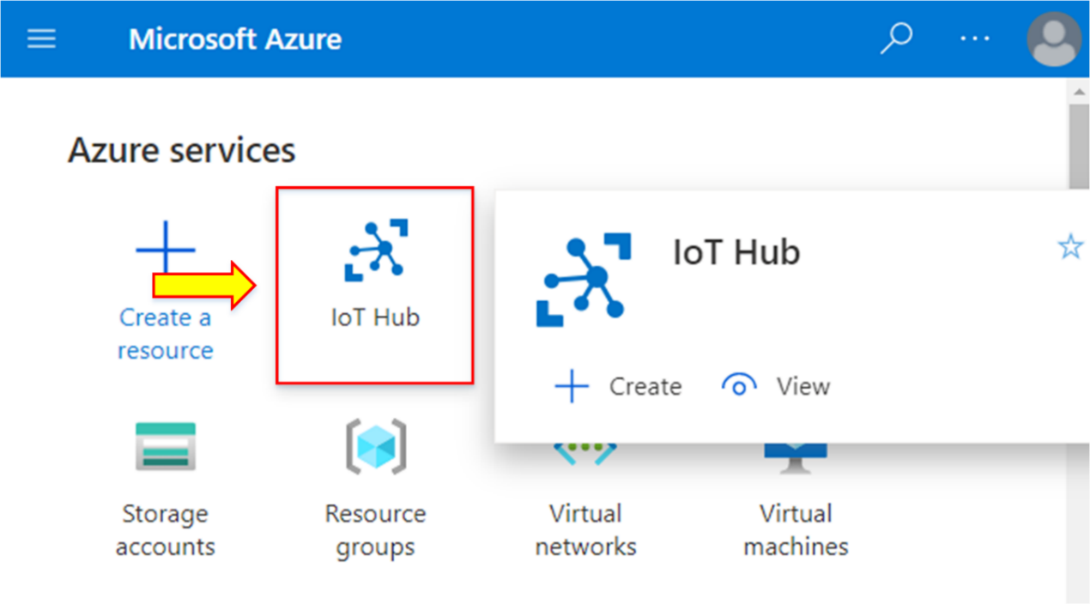

1. To create an IoT Hub, click on the **+ Add”=** option present at the top given options.

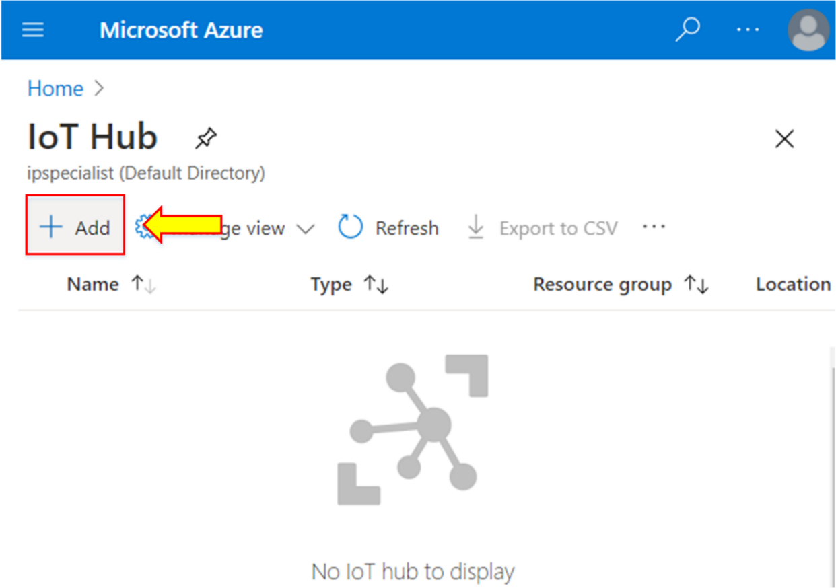

1. Now, enter the **Basics** details. Inside the **Project details,** select your subscription and create a new resource group, **ipsrg.**
2. Select your nearest region.
3. Write the unique name of the IoT Hub.
4. Click on **Next: Networking >.**

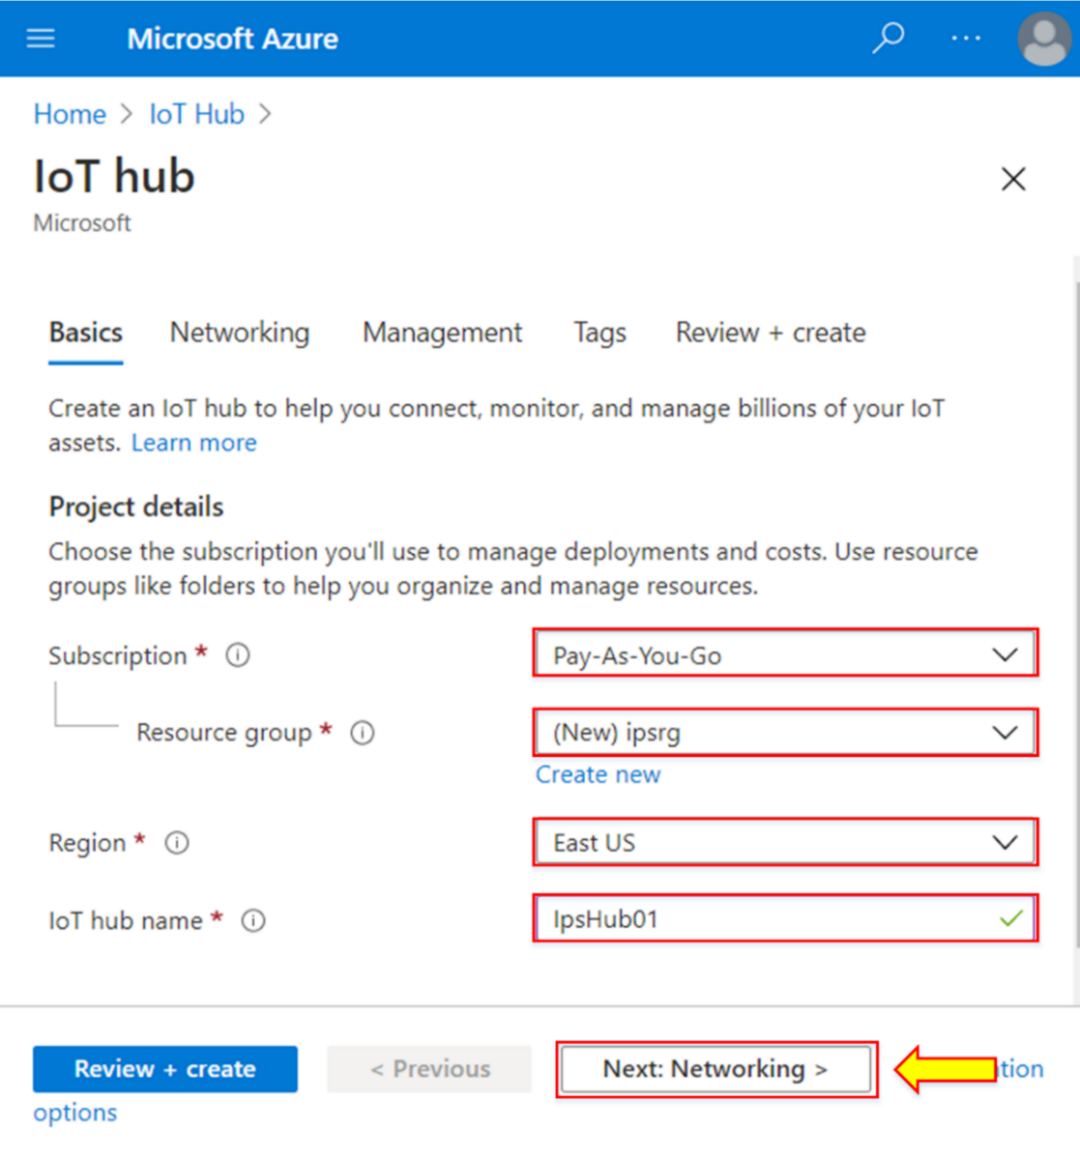

1. Check the connectivity method set as **Public endpoint (all networks).**
2. Click on **Review + create.**

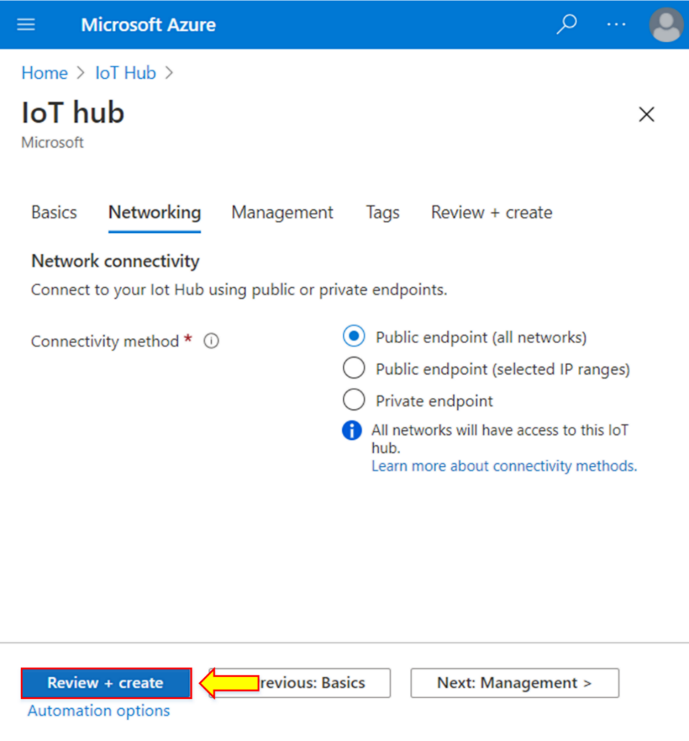

1. After verifying the details, click on **Create.**

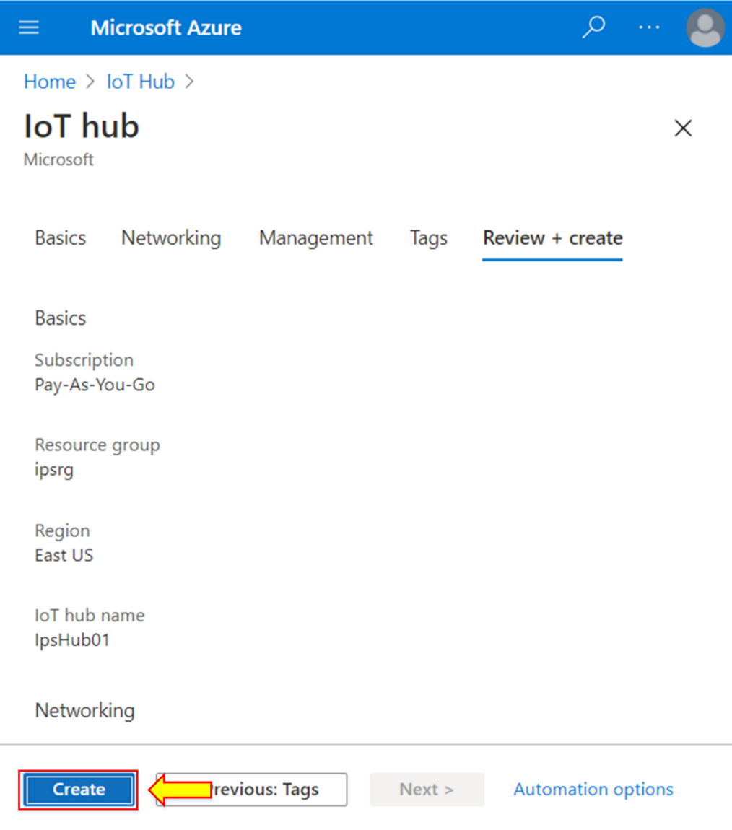

1. When the deployment is completed, click on **Go to resource.**

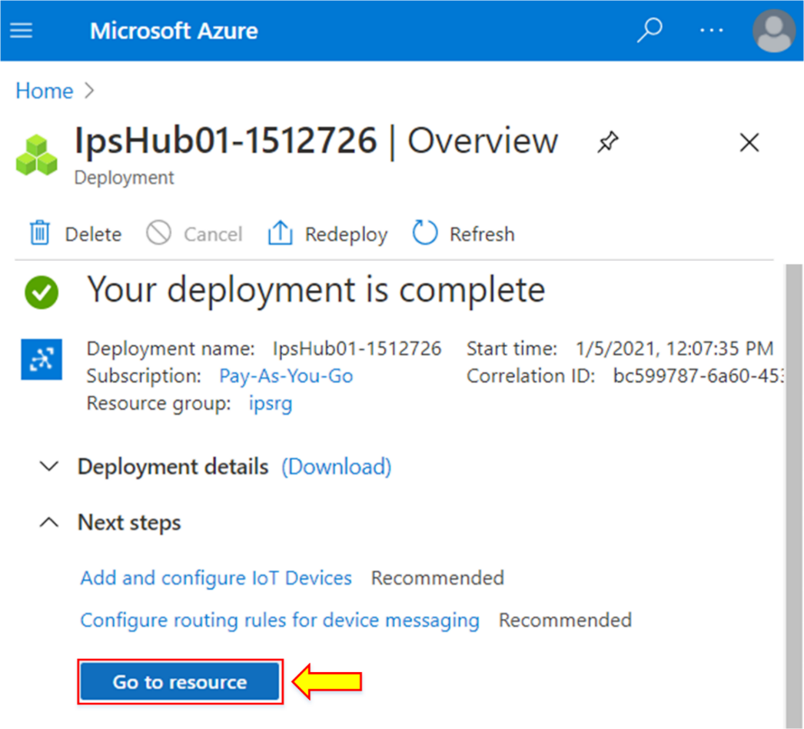

1. The overview page will appear, containing all the configuration details entered during the creation of the IoT Hub.

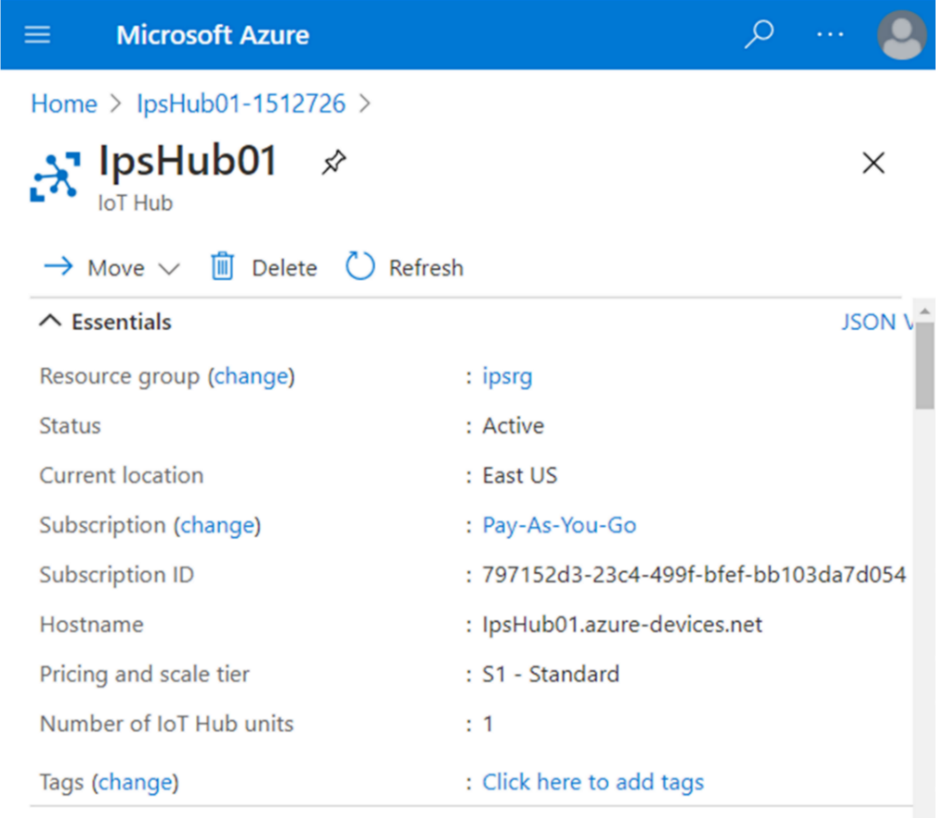

1. To register a device in this IoT Hub, go to the left side of the given menu and click on **IoT devices** present inside **Explorers.**

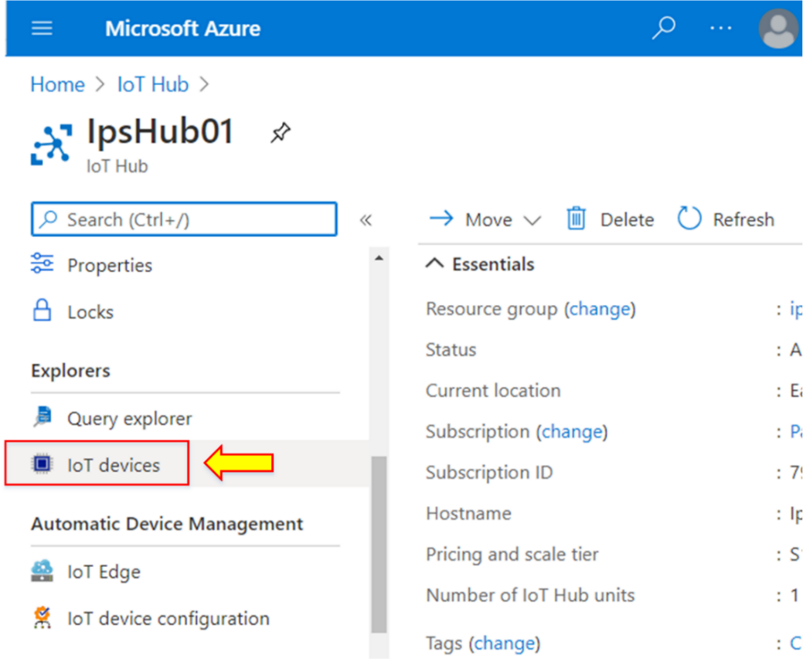

1. To create a new device, click on the **+ New** option at the top of the page.

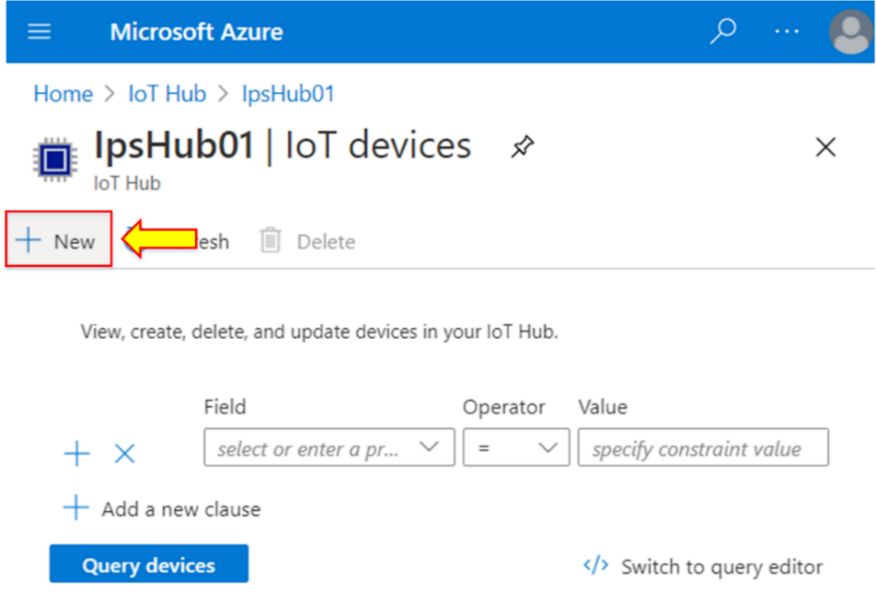

1. The new dialog window will appear. There is a need to supply a device ID. Therefore, write the **Device ID** as **IoT Device1.**

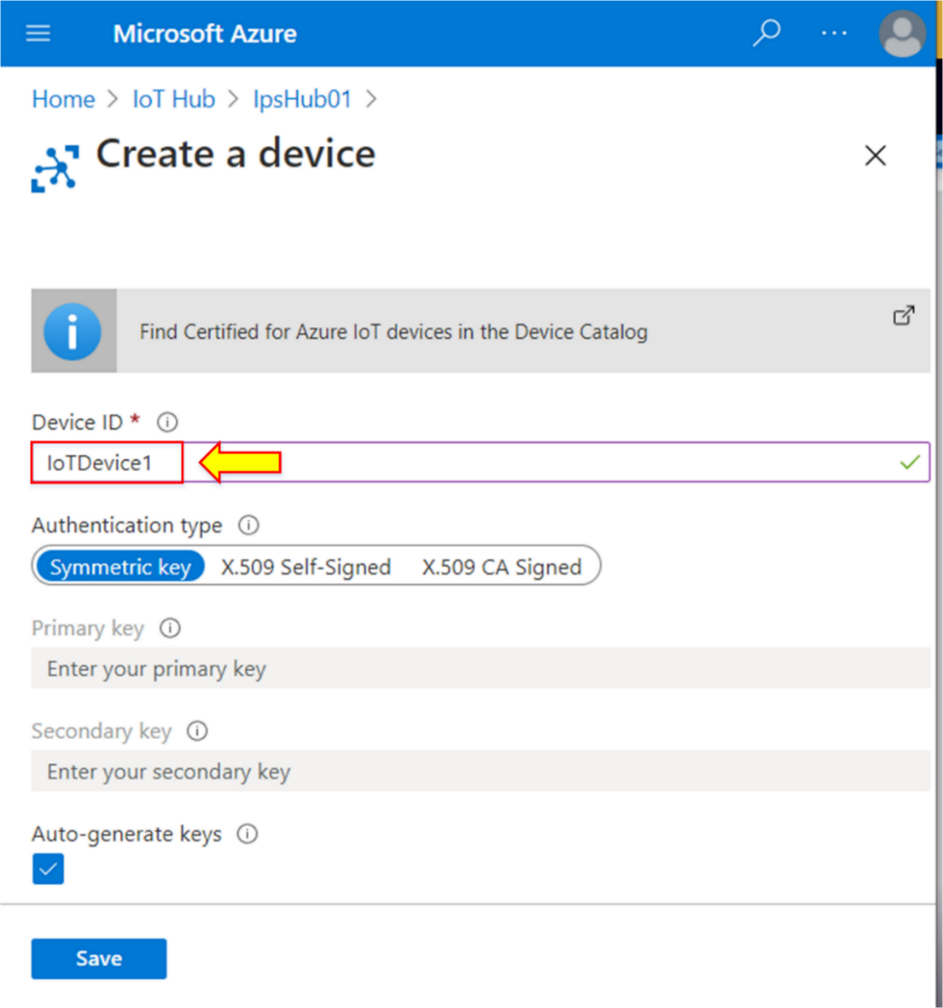

1. For **Authentication type,** there are different methods available to choose from. You can use **X.509 Self-Signed certificate** for a custom solution.

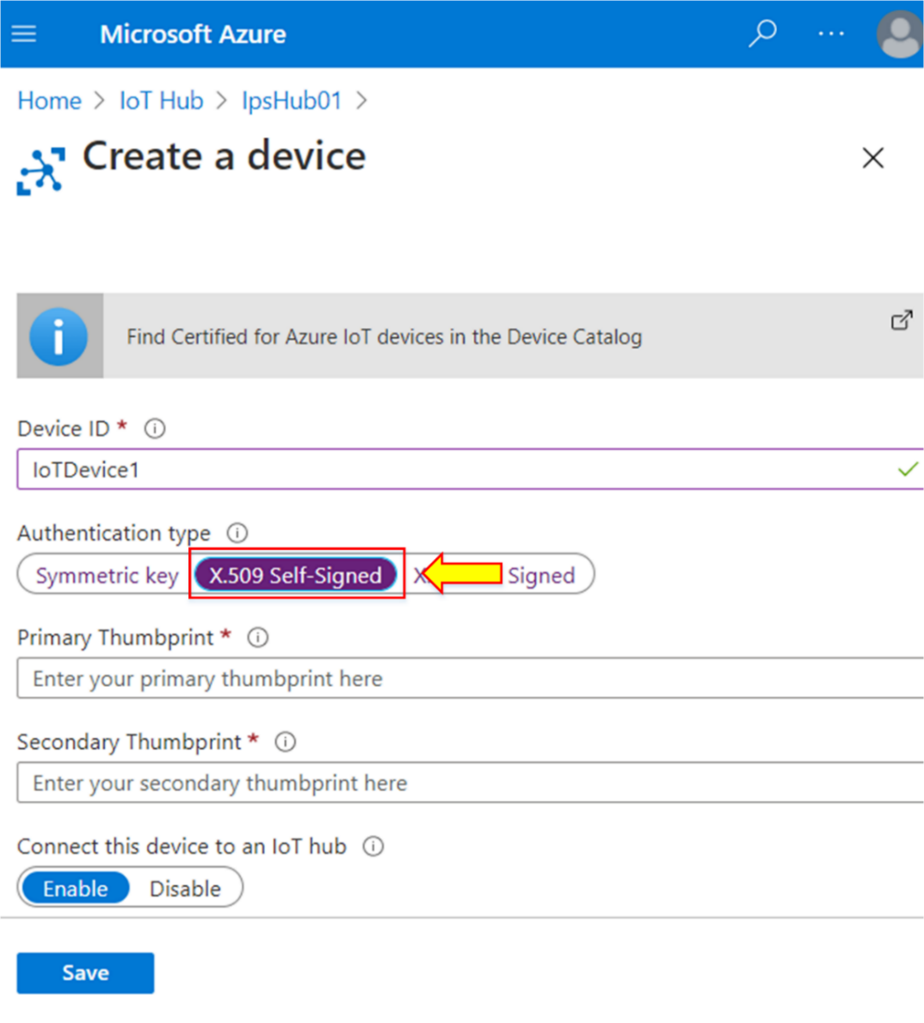

**Note:** Usually, SSL/TSL certificates are self-signed certificates. These certificates are not useful for public-facing applications.

1. If you want to use the public key certificate signed by Certificate Authority (CA), you can use the **X.509 CA Signed** option.

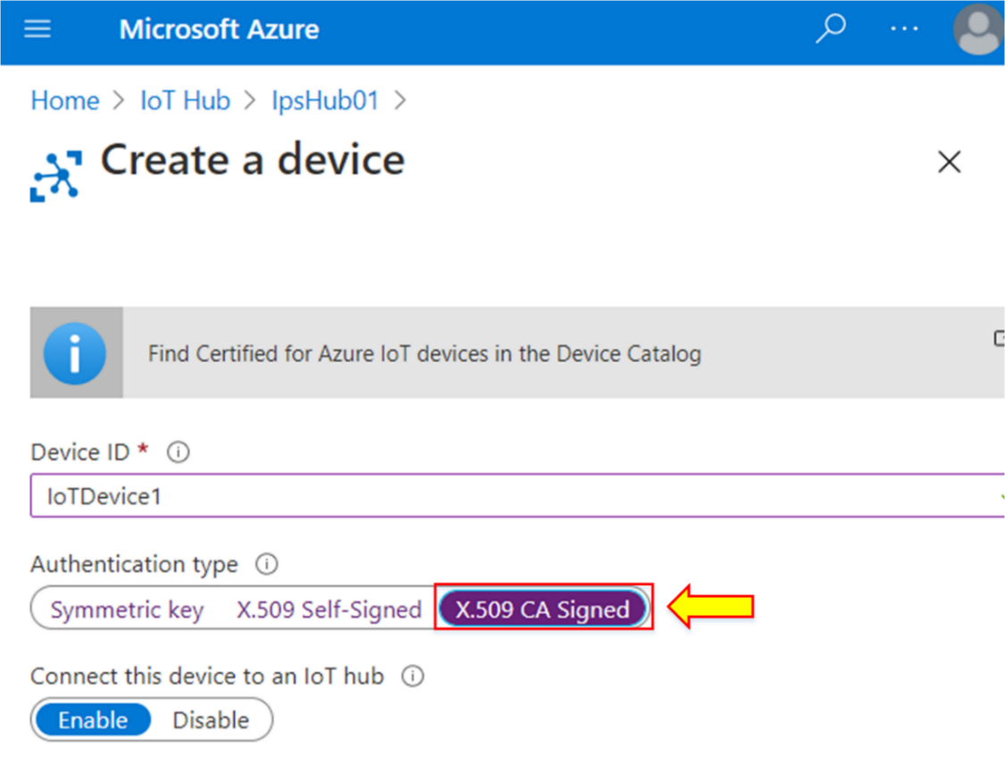

1. In this case, we will use **Symmetric Keys** as the **Authentication type.**
2. Enable the **Auto-generated keys** option. Leave the remaining options as default.
3. Click on **Save.**

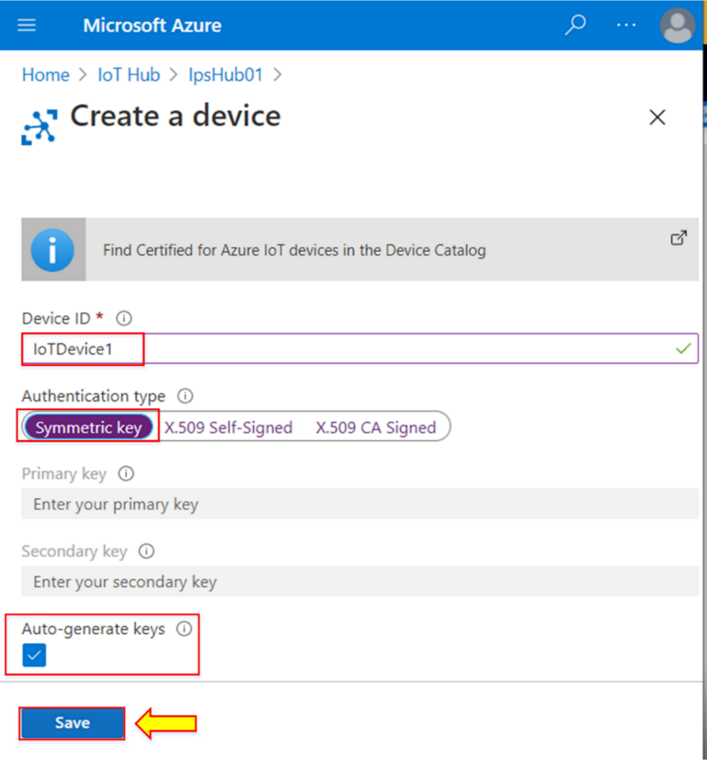

**Note:** Symmetric keys are the quickest way to connect the device to an Azure IoT Hub.

1. After creating a new IoT device, we will connect this device to the IoT Hub.

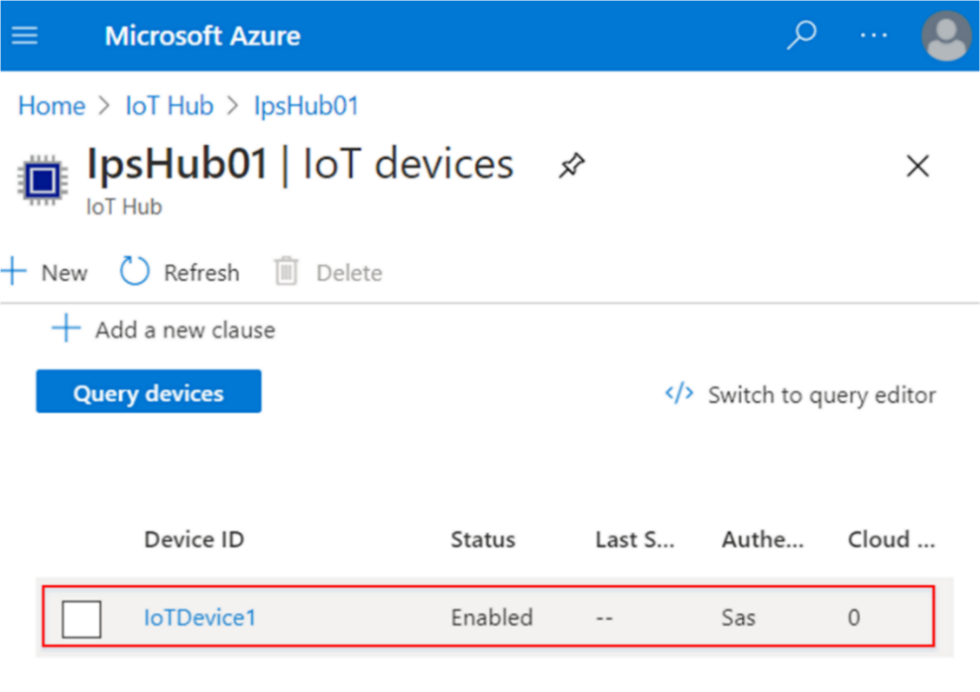

1. A simulated device is required to get the device talking to the Azure IoT Hub. In this lab, we will use the Microsoft Raspberry Pi simulator.
2. The online simulator is shown below.

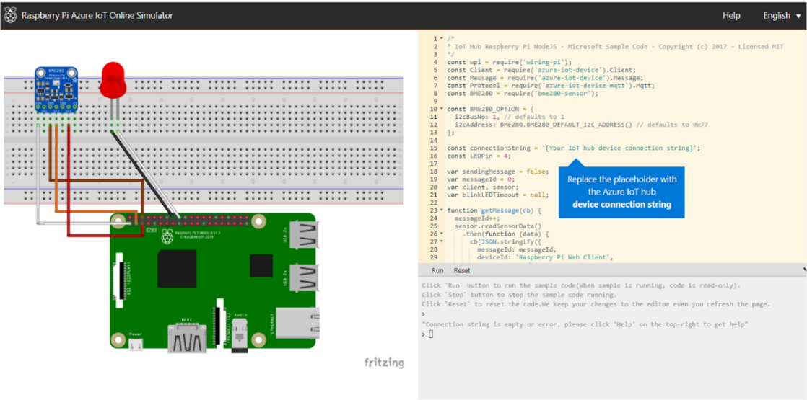

**Note:** When you click on the **Run** option, it will require a connection string to run.

1. Go back to the IoT devices page to connect to the Azure IoT Hub. Click on your recently created device.

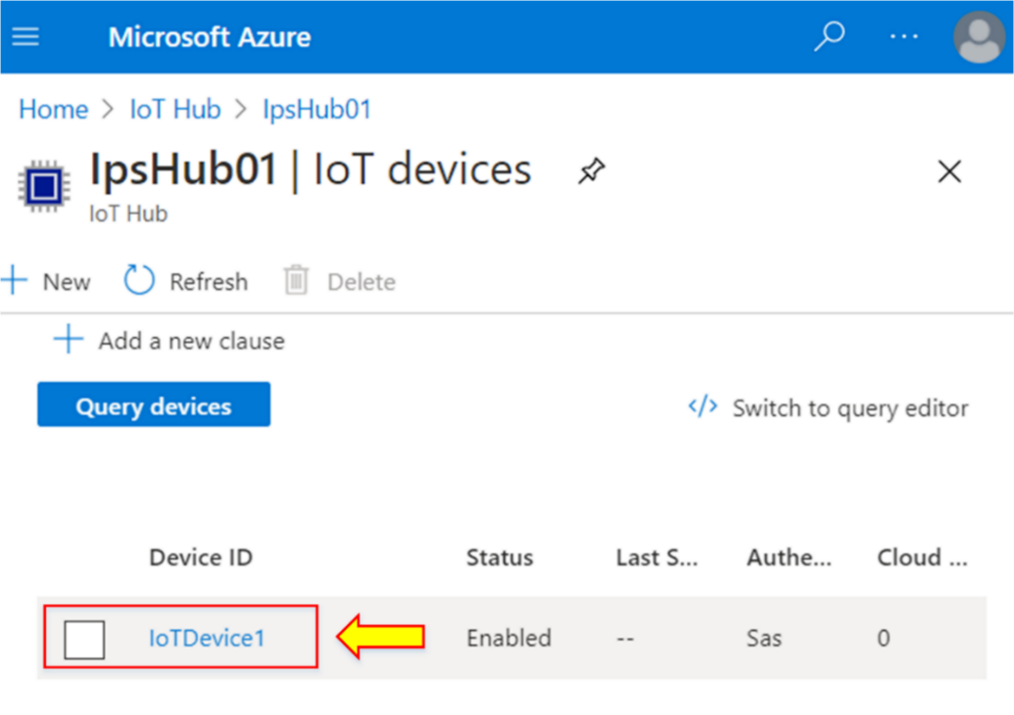

1. The details of the device will appear.
2. The primary and secondary keys will be auto-generated, which means that the primary and secondary connection strings also exist in the device registry.
3. Copy the **Primary Connection String.**

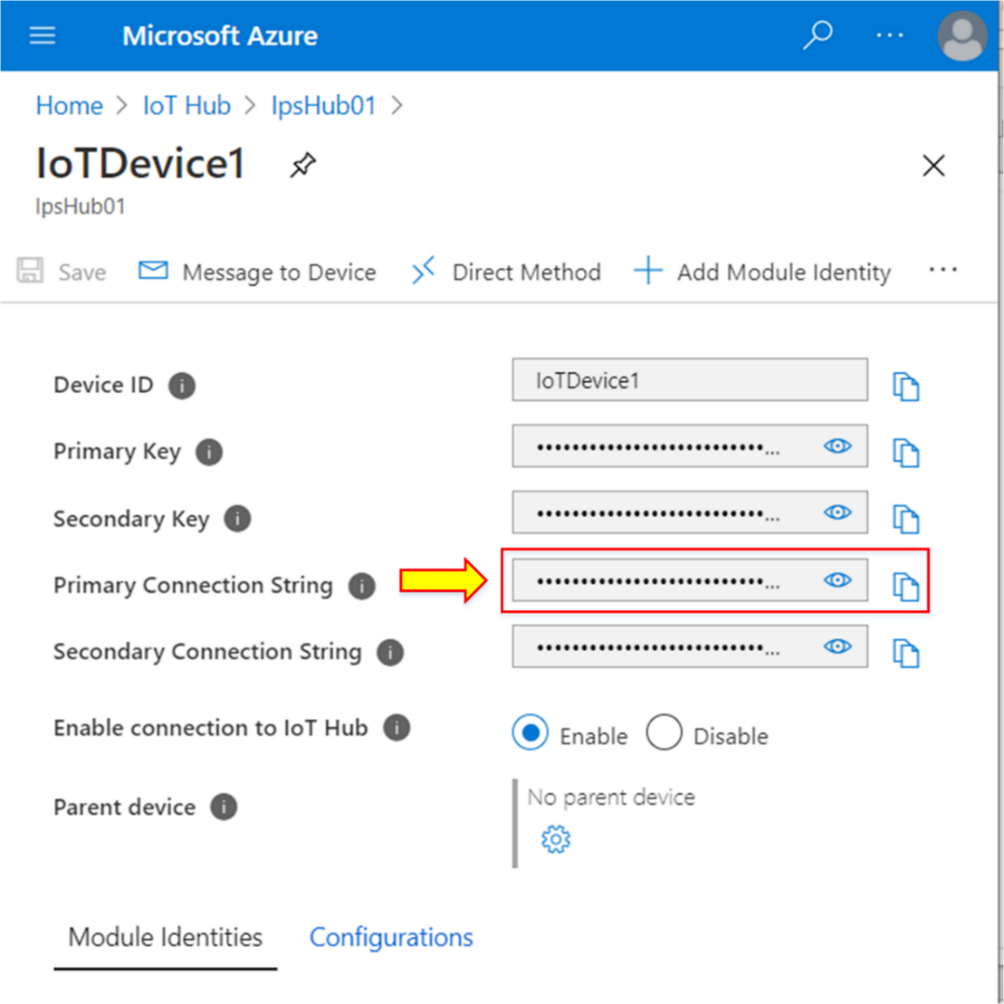

1. Go to the Raspberry Pi online simulator, and paste that connection string in place of the **connectionString** command into the coding area.
2. Click **Run** on the console window.

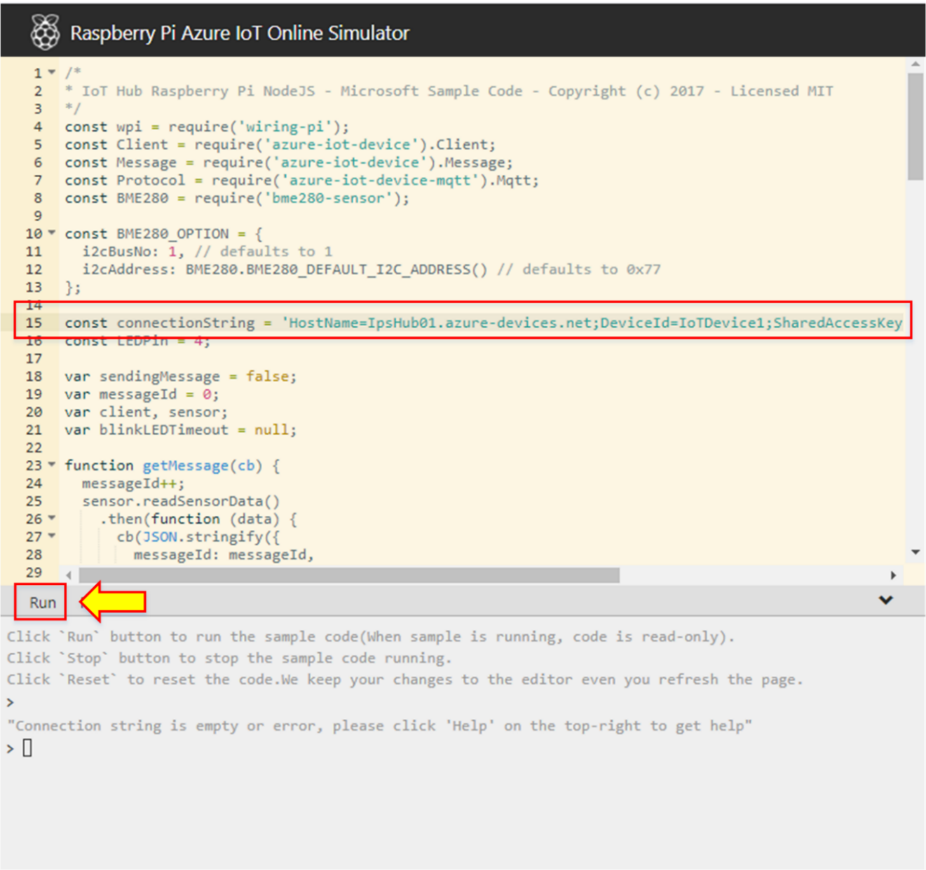

1. Within a few seconds, you can see the statement about sending the telemetry data to your Azure IoT Hub.

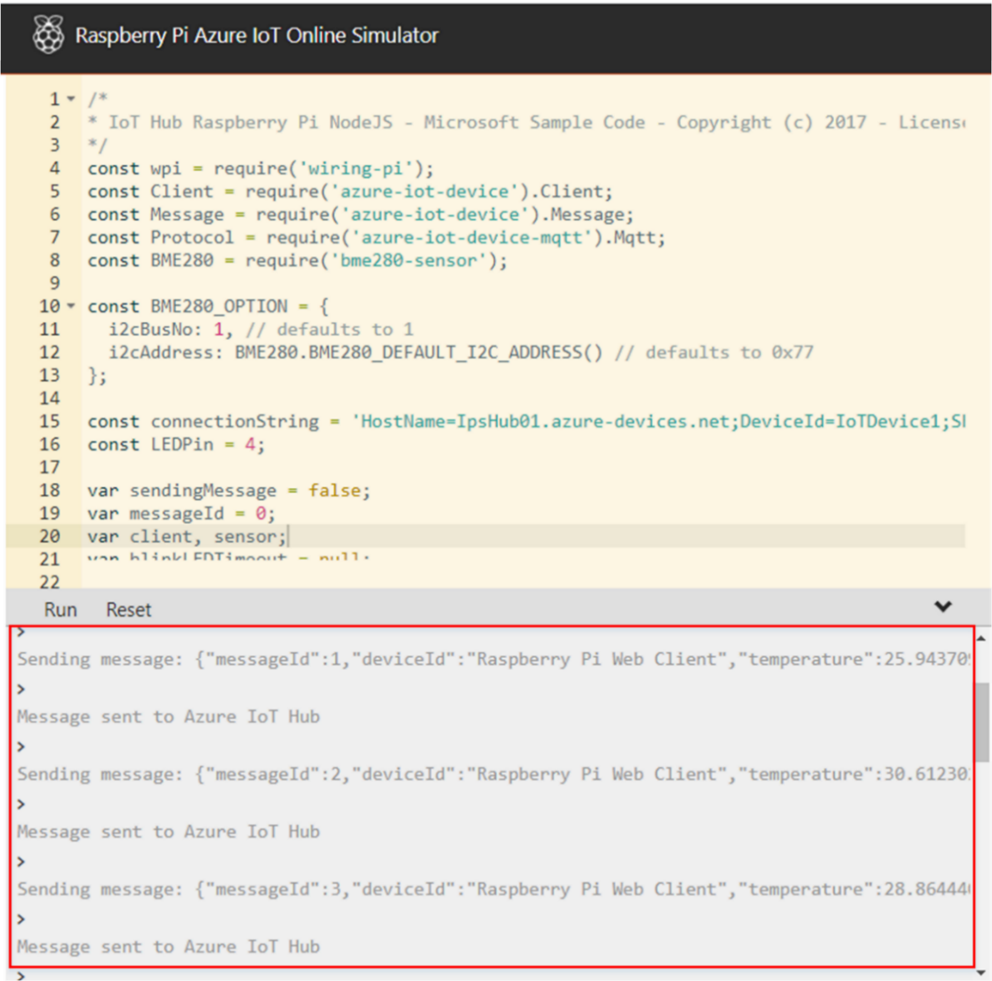

1. Furthermore, you will see the LED blinking in response to the code.

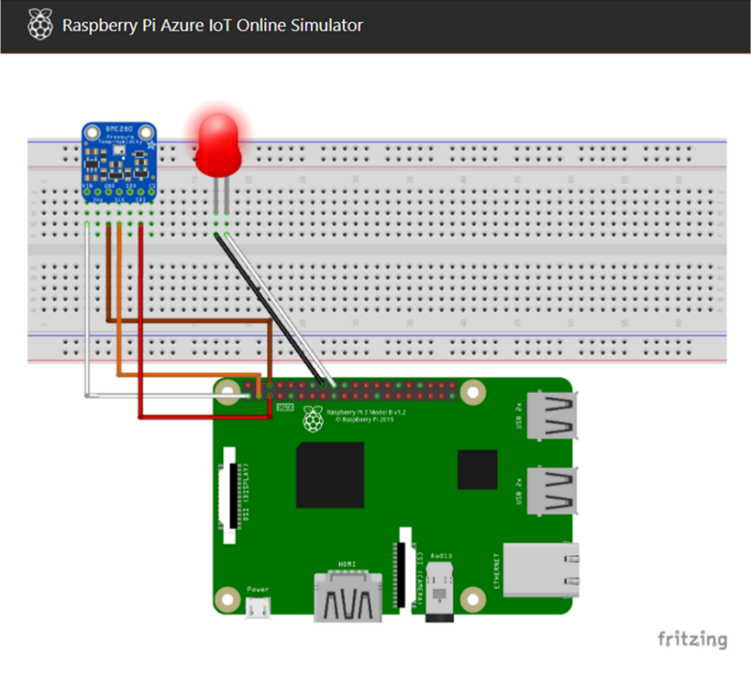

## Lab 7-02: Azure AI Service

### Service Introduction

Azure AI services encompass a suite of artificial intelligence tools and capabilities offered by Microsoft Azure, enabling developers to integrate advanced AI functionalities into their applications with ease. These services cover a wide range of AI capabilities, including machine learning, natural language processing, computer vision, and speech recognition. Azure AI services, such as Azure Machine Learning, Azure Cognitive Services, and Azure Bot Services, provide pre-built models, APIs, and development frameworks that facilitate the creation of intelligent applications. Developers can leverage these services to build sophisticated features like image recognition, language understanding, and conversational interfaces, ultimately enhancing the overall user experience and functionality of their applications. Azure AI services empower organizations to harness the power of artificial intelligence without the need for extensive expertise, accelerating the adoption of AI-driven solutions across various industries.

### Problem

A company wants to improve its office attendance and surveillance system by enabling face recognition service. How can this be done?

### Solution

The company can use the Azure Artificial Intelligence (AI) service for Face Recognition. This service will analyze the picture of a person by facial expression, hair, age, and accessories, then declare the result based on the information collected.

|  |
| --- |
| **Step-by-Step Guide**   1. Open **Microsoft AI**.      1. Go to the Face and Emotion Recognition service of Microsoft AI. 2. Click on the **Try it out** button.      1. The face and Emotion Recognition service page will open and display as shown below. 2. Click on **Add Photo** in both PHOTO 1 and PHOTO 2.      1. On PHOTO 1, upload the picture of the company’s employee from the company’s library. 2. On PHOTO 2, upload the picture of an unknown person. 3. The face recognition service will scan the photos and declare the result, as shown below.      1. Take pictures of the same person for PHOTO 1 and PHOTO 2. 2. The result will show a 100% match, which means both persons are the same. |